C01
ASSESSMENT TOOL 1
NAME:KONGARA SAI
REGISTRATION NUMBER:192365025
COURSE NAME: INTERNET PROGRAMMING
COURSE CODE: CSA4308

1: Online Symposium Portal
A college is developing an online symposium registration portal. The following HTML
structure and HTTP interaction is observed:
&lt;form action=&quot;/register&quot; method=&quot;POST&quot;&gt;
&lt;input type=&quot;text&quot; name=&quot;name&quot;&gt;
&lt;input type=&quot;email&quot; name=&quot;email&quot;&gt;
&lt;button&gt;Submit&lt;/button&gt;
&lt;/form&gt;
When a student submits the form, the browser sends an HTTP request to the server, and the
server responds accordingly.
Questions:
1. Identify appropriate HTML5 semantic elements missing in the structure.
2. Modify the structure to make it standards-compliant.
3. Interpret the HTTP request generated during form submission.
4. Analyze the HTTP response cycle from server to browser.
5. Suggest improvements for usability and accessibility.

ANSWER:

1. Identify appropriate HTML5 semantic elements missing in the structure.
The given HTML structure contains only a <form> element with input fields and a button. The following HTML5 semantic elements are missing:
- <header> – Defines the header section of the webpage.
- <main> – Defines the main content of the webpage.
- <section> – Groups related content, such as the registration form.
- <h1> or <h2> – Provides a heading for the registration page.
- <label> – Provides labels for the input fields and improves accessibility.
- <fieldset> – Groups related form controls.
- <legend> – Provides a caption for the <fieldset>.
- <footer> – Defines the footer section of the webpage.

2. Modify the structure to make it standards-compliant.
<!DOCTYPE html>
<html lang="en">
<head>
<meta charset="UTF-8">
<meta name="viewport" content="width=device-width, initial-scale=1.0">
<title>Online Symposium Registration</title>
</head>

<body>

<header>
<h1>Online Symposium Registration Portal</h1>
</header>

<main>
<section>
<h2>Student Registration</h2>

<form action="/register" method="POST">
<fieldset>
<legend>Registration Details</legend>

<label for="name">Full Name:</label>
<input type="text" id="name" name="name" required>

<br><br>

<label for="email">Email Address:</label>
<input type="email" id="email" name="email" required>

<br><br>

<button type="submit">Register</button>
</fieldset>
</form>
</section>
</main>

<footer>
<p>&copy; 2026 Online Symposium</p>
</footer>

</body>
</html>
The modified structure uses HTML5 semantic elements and proper labels for the form controls. The required attribute ensures that the user enters the necessary information before submitting the form.

3. Interpret the HTTP request generated during form submission.
When a student enters the name and email address and clicks the Register button, the browser sends an HTTP POST request to the /register URL specified in the action attribute.
For example, if the student enters:
Name: John Doe
Email: john@example.com
The browser sends a request similar to:
POST /register HTTP/1.1
Host: example.com
Content-Type: application/x-www-form-urlencoded

name=John+Doe&email=john%40example.com
The request can be interpreted as follows:
- POST is the HTTP method used to send data to the server.
- /register is the URL path where the form data is submitted.
- Host identifies the server receiving the request.
- Content-Type specifies the format of the submitted form data.
- The request body contains the values entered by the student.
The submitted data is encoded as:
name=John+Doe&email=john%40example.com
The @ symbol in the email address is encoded as %40.

4. Analyze the HTTP response cycle from server to browser.
The HTTP response cycle occurs in the following steps:
- The student fills in the registration form.
- The student clicks the Register button.
- The browser creates an HTTP POST request.
- The browser sends the request to the /register endpoint.
- The server receives the request and extracts the submitted data.
- The server validates the name and email address.
- The server may store the registration details in a database.
- The server generates an HTTP response.
- The response is sent back to the browser.
- The browser processes the response and displays the result to the student.
For example, a successful response may be:
HTTP/1.1 200 OK
Content-Type: text/html; charset=UTF-8
The response body may contain:
<h1>Registration Successful</h1>
<p>Thank you for registering for the symposium.</p>
The complete communication cycle can be represented as:
Student
↓
Web Browser
↓
POST /register Request
↓
Web Server
↓
Validate and Process Data
↓
Database
↓
Web Server
↓
HTTP Response
↓
Web Browser
↓
Registration Result Displayed
If the registration is successful, the server can redirect the browser to a confirmation page using the Post/Redirect/Get (PRG) technique. This helps prevent duplicate registrations when the user refreshes the page.

5. Suggest improvements for usability and accessibility.
The following improvements can be made to the online symposium registration portal:
- Use proper labels: Every input field should have a corresponding <label> element so that users and screen readers can understand the purpose of each field.
- Use required fields: The required attribute should be used for mandatory fields.
- Use suitable input types: The email input type should be used for email addresses to provide basic validation.
- Provide clear error messages: The system should display meaningful error messages when incorrect or incomplete information is entered.
- Provide confirmation messages: After successful registration, the user should receive a clear confirmation message.
- Support keyboard navigation: All form elements should be accessible using the keyboard.
- Use autocomplete: The autocomplete attribute can be used to make entering personal information easier and faster.
- Responsive design: The registration form should work properly on desktops, tablets, and mobile devices.
- Use HTTPS: HTTPS should be used to protect the student's personal information while it is being transmitted to the server.
- Prevent duplicate submissions: The Post/Redirect/Get technique can be used after successful submission to prevent duplicate registrations.
- Accessible error handling: Error messages should be clearly associated with the relevant input fields so that users with disabilities can understand and correct errors.
- Simple and clear interface: The form should have a clean layout, readable text, sufficient spacing, and clearly visible buttons to provide a better user experience.

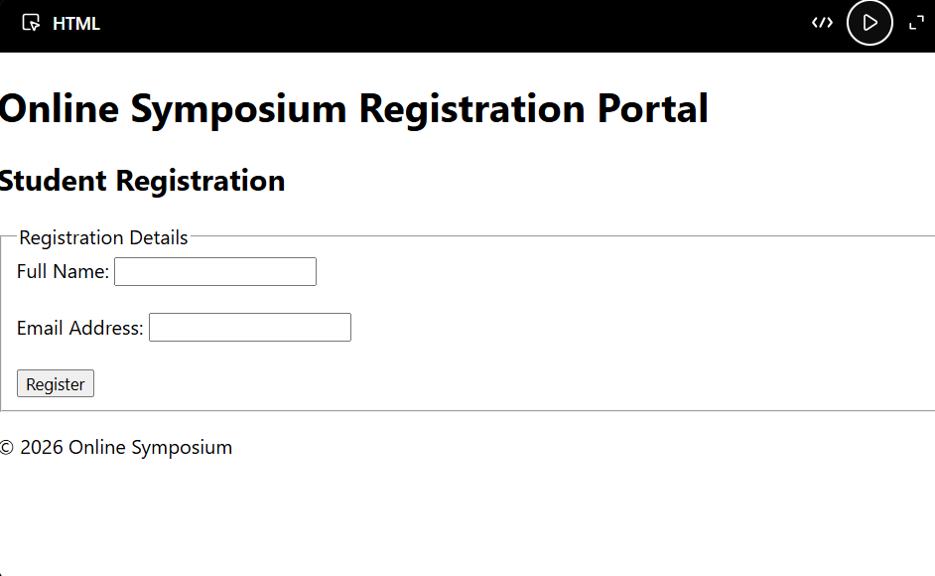

2: Cross-Browser Compatibility Issue

A company website shows inconsistent layout across browsers. The following HTML snippet
is used:
&lt;html&gt;
&lt;head&gt;
&lt;title&gt;Company&lt;/title&gt;
&lt;/head&gt;
&lt;body&gt;
&lt;div&gt;
&lt;h1&gt;Welcome
&lt;p&gt;About us
&lt;/div&gt;
&lt;/body&gt;
&lt;/html&gt;
Questions:
1. Identify improper nesting and missing closing tags.
2. Analyze how different browsers may interpret this structure.
3. Identify missing semantic elements (e.g., header, section).
4. Provide a corrected W3C-compliant HTML structure.
5. Suggest techniques to ensure cross-browser compatibility.

ANSWER:
1. Identify improper nesting and missing closing tags.
The given HTML code has improper nesting and missing closing tags.
The problems are:
- The <h1> tag is not closed with </h1>.
- The <p> tag is not closed with </p>.
- The <p> element is placed inside the <h1> element because the <h1> closing tag is missing.
- The <h1> and <p> elements are not properly structured.
- The <div> is closed without properly closing the elements inside it.
- Semantic HTML5 elements such as <header>, <main>, <section>, and <footer> are missing.
The incorrect structure is:
<div>
<h1>Welcome
<p>About us
</div>
The correct structure should close each element properly:
<div>
<h1>Welcome</h1>
<p>About us</p>
</div>

2. Analyze how different browsers may interpret this structure.
Different web browsers have HTML parsers that attempt to correct invalid or incomplete HTML automatically.
When the browser encounters the missing </h1> and </p> tags, it may automatically insert missing closing tags or rearrange the document structure in the Document Object Model (DOM).
As a result:
- One browser may automatically close the <h1> element before the <p> element.
- Another browser may construct a slightly different DOM structure.
- The default CSS styles applied to <h1> and <p> may produce different visual results.
- The spacing, margins, font sizes, and positioning may appear inconsistent.
- Older browsers may handle invalid markup differently from modern browsers.
Although modern browsers are generally good at handling invalid HTML, relying on automatic error correction is not recommended. Valid HTML should be used to ensure consistent rendering across browsers.

3. Identify missing semantic elements.
The given HTML structure does not use appropriate HTML5 semantic elements.
The following elements can be added:
- <header> – Represents the header area of the company website.
- <main> – Represents the main content of the webpage.
- <section> – Groups related content, such as the "About Us" section.
- <footer> – Represents the footer of the webpage.
- <h1> – Provides the main heading of the page.
- <p> – Contains the paragraph or description.
Using semantic elements improves the structure, readability, accessibility, and search engine optimization of the website.

4. Provide a corrected W3C-compliant HTML structure.
<!DOCTYPE html>
<html lang="en">

<head>
<meta charset="UTF-8">
<meta name="viewport" content="width=device-width, initial-scale=1.0">
<title>Company</title>
</head>

<body>

<header>
<h1>Welcome</h1>
</header>

<main>
<section>
<h2>About Us</h2>
<p>About us</p>
</section>
</main>

<footer>
<p>&copy; 2026 Company. All rights reserved.</p>
</footer>

</body>

</html>
This structure is properly nested and contains all required closing tags. It also uses HTML5 semantic elements to create a clear document structure.

5. Suggest techniques to ensure cross-browser compatibility.
The following techniques can be used to ensure cross-browser compatibility:
- Use valid HTML: Follow HTML5 standards and properly close all elements.
- Use <!DOCTYPE html>: This enables standards mode in modern browsers and prevents browsers from using quirks mode.
- Use semantic HTML: Use elements such as <header>, <main>, <section>, and <footer> correctly.
- Validate HTML and CSS: Use W3C validation tools to identify syntax errors and invalid markup.
- Use CSS resets or normalization: CSS reset or Normalize.css can help reduce differences in default browser styles.
- Use responsive design: Use CSS media queries and flexible layouts to support different screen sizes and devices.
- Test on multiple browsers: Test the website on browsers such as Chrome, Firefox, Microsoft Edge, and Safari.
- Avoid browser-specific code: Avoid unnecessary browser-specific HTML and CSS features.
- Use feature detection: Check whether a browser supports a particular feature before using it.
- Keep browsers updated: Test with modern and commonly used browser versions.
- Use progressive enhancement: Build the basic functionality first and then add advanced features for browsers that support them.
- Use consistent CSS: Define styles explicitly instead of depending on different browsers' default styles.
By following these techniques, developers can reduce differences in how webpages are displayed and provide a consistent user experience across different browsers and devices.

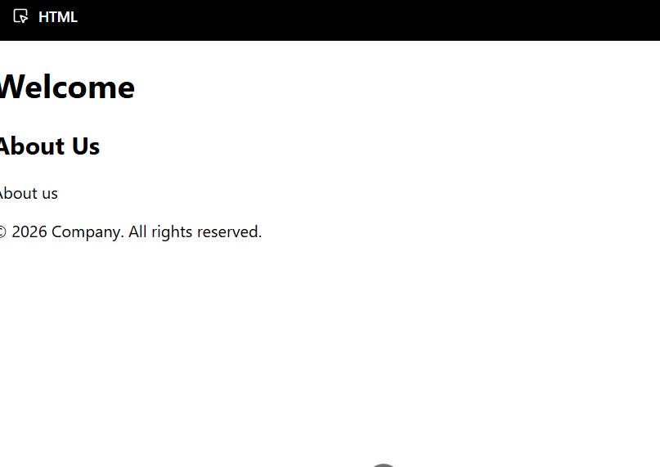

3: Form Submission Failure
A web application fails to send form data to the server. The following configuration is
observed:
&lt;form action=&quot;/submit&quot; method=&quot;GET&quot;&gt;
&lt;input type=&quot;text&quot; name=&quot;username&quot;&gt;
&lt;input type=&quot;password&quot; name=&quot;password&quot;&gt;
&lt;button type=&quot;button&quot;&gt;Login&lt;/button&gt;
&lt;/form&gt;
Questions:
1. Identify issues in the form configuration.
2. Analyze why the HTTP request is not triggered.
3. Interpret the role of GET method in this scenario.
4. Propose a corrected implementation.
5. Suggest improvements for secure data transmission.

ANSWER:

1. Identify issues in the form configuration.
The following issues are present in the given form:
- The button uses type="button" instead of type="submit".
- A button with type="button" does not submit the form.
- The GET method is not suitable for sending sensitive information such as passwords.
- The username and password fields do not have the required attribute.
- The form does not use <label> elements for better accessibility.
- HTTPS should be used to securely transmit login information.

2. Analyze why the HTTP request is not triggered.
The HTTP request is not triggered because the button is defined as:
<button type="button">Login</button>
The type="button" creates a normal button and does not submit the form.
To trigger the form submission, the button must be changed to:
<button type="submit">Login</button>
When the user clicks the submit button, the browser collects the values of the form fields and sends them to the URL specified in the action attribute.

3. Interpret the role of GET method in this scenario.
The GET method is used to request data from a server. When a form uses the GET method, the submitted form data is appended to the URL as query parameters.
For example, if the user enters:
Username: john
Password: 12345
The URL may become:
/submit?username=john&password=12345
The GET method is not suitable for login forms because the password can appear in the URL. This information may be stored in browser history, server logs, proxy logs, or other systems.
Therefore, the POST method should be used for login forms.

4. Propose a corrected implementation.
<!DOCTYPE html>
<html lang="en">

<head>
<meta charset="UTF-8">
<meta name="viewport" content="width=device-width, initial-scale=1.0">
<title>Login</title>
</head>

<body>

<main>
<h1>Login</h1>

<form action="/submit" method="POST">

<label for="username">Username:</label>
<input
type="text"
id="username"
name="username"
required
>

<br><br>

<label for="password">Password:</label>
<input
type="password"
id="password"
name="password"
required
>

<br><br>

<button type="submit">Login</button>

</form>
</main>

</body>

</html>
In the corrected implementation:
- method="POST" is used instead of GET.
- type="submit" ensures that the form is submitted.
- required ensures that the fields cannot be left empty.
- <label> elements improve accessibility.
- type="password" hides the password characters while typing.
The browser will send a request similar to:
POST /submit HTTP/1.1
Content-Type: application/x-www-form-urlencoded

username=john&password=12345

5. Suggest improvements for secure data transmission.
The following improvements should be implemented:
- Use HTTPS: HTTPS encrypts the communication between the browser and server and protects login credentials during transmission.
- Use POST: The POST method should be used instead of GET for submitting passwords and other sensitive information.
- Use password hashing: Passwords should never be stored as plain text. The server should store passwords using secure password-hashing algorithms.
- Perform server-side validation: The server must validate all submitted data because client-side validation can be bypassed.
- Use secure cookies: Authentication cookies should use appropriate security attributes such as Secure and HttpOnly.
- Use CSRF protection: CSRF tokens or equivalent protections should be implemented where appropriate.
- Avoid sensitive information in URLs: Passwords and other confidential information should never be sent as URL query parameters.
- Implement secure session management: The application should use secure session identifiers and properly manage user sessions.
- Prevent brute-force attacks: Rate limiting and other login protection mechanisms should be implemented.
- Use proper error messages: The application should avoid revealing whether a username exists when login fails.
Therefore, the primary reason for the form submission failure is the use of type="button". Changing it to type="submit" will trigger form submission. For a login form, POST should be used instead of GET, and the form should be submitted over HTTPS for secure data transmission.

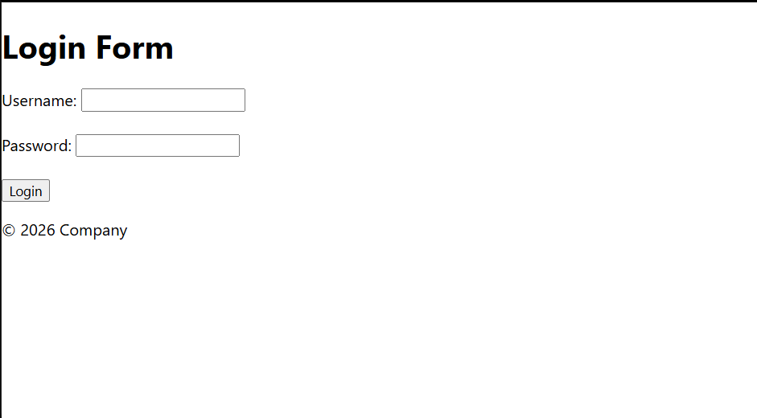

Code of Conduct:
I KONGARA SAI/192365025certify that this submission is my
original work and that I have adhered to the guidelines specified for this assessment.
I understand that any violation of academic integrity rules will result in disciplinary
action.
Signature of the student:
K.Sai

